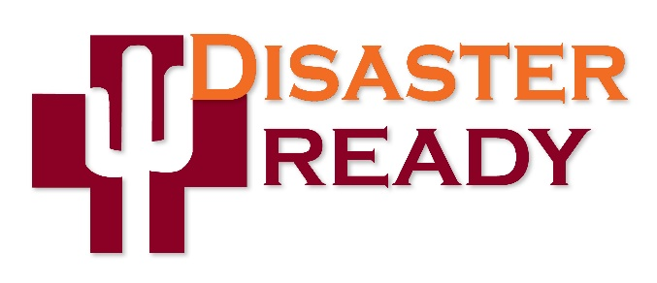
Emergency Operations Plan / NHICS During COVID-19 Management
Have you Activated NHICS and Incident Command?

For the better part of the last month, the management of COVID-19 in long term care facilities has been at the forefront of your operations. Now that this infectious disease outbreak has impacted all sectors of our society and both a federal and state public health emergency has been declared, it is important to ask this question, “Have you activated your Emergency Operations Plan (EOP) and are you using the Incident Command System to manage COVID-19?”

What and Why?
- While COVID-19 does not fit the definition of a “traditional” emergency or disaster, it is nonetheless an incident that needs to be managed in the same manner as a fire, flood, evacuation, power failure or any type of adverse event at your facility.

- Since February 2019, CMS has required skilled nursing facilities (SNF) to recognize Emergent Infection Disease (EID) as a potential hazard in their Hazard Vulnerability Assessment (HVA). Clearly, the on-set of COVID-19 has proven the threat as real. Whenever a hazard like an EID has been identified, SNFs are required to have a plan in place to address that specific hazard.

How and When?
No doubt you have participated in the Disaster Ready-sponsored NHICS training with your facility team over the last few years. Now is the time to put it into action!

- If you haven’t already… activate your EOP and establish an Emergency Operations Center (EOC). At the very least, an Incident Commander (IC) should be in place along with any other of the Command Staff or General Staff positions needed for the duration of EOP activation. Go to the Disaster Ready website to access all of the tools associated with NHICS.

- The following NHICS forms should be used throughout the management of COVID-19 along with any other forms that meet your facility’s specific incident management needs:

NHICS 200- Quick Start- Incident Action Plan (IAP) - Set up at the beginning of your activation
NHICS 201- Incident Briefing and Operation Log- Used to record the incident as it progresses
NHICS 204- Assignment List
NHICS 214- Activity Log
NHICS 252- Section Personnel Time Sheet
- Remember your NHICS Training! When managing an emergency or disaster with NHICS you are “managing by objective.” NHICS provides your team a “framework” of response by establishing SMART objectives (Specific, Measurable, Attainable, Realistic, and Timed) that are aligned with an Operational Period to measure success and progress. SMART objectives are typically illustrated with a word or a phrase. Here are some examples SMART objectives that would likely be developed by your facility’s Incident Management Team (IMT):

- Staff Safety
- Resident Safety
- Social Distancing
- Facility lockdown
- Prevention of Spread
- Communication- Internal
- Communication- External
- Coordination (ADHS, AzCHER, public health, etc.)

Once the SMART objectives are established during an Incident Action Planning (IAP) meeting, the IC will establish an Operational Period to achieve the SMART objective on your NHICS forms. When an objective is met either in advance of the end of the operational period or when the operational period expires, a new IAP convenes to establish tactics and strategies to achieve the objectives that have not been completed or develop new SMART objectives as the incident moves forward. The NHICS forms and Job Action Sheets provide the tools needed to “manage by objective.”

- There is an Incident Response Guide (IRG) in NHICS that will provide additional information on Infectious Disease to help guide the response and recovery phases of the incident.

- NHICS Job Action Sheets (JAS) should also be used for each position on Incident Management Team (IMT) that is activated.

Command Staff:
- Incident Commander
- Safety Officer
- Medical Director/Specialist
- Public Information Officer/Liaison
- Scribe/Runner
Operations Section:
- Operations Section Chief
- Resident Services Branch Director
- Infrastructure Branch Director
Planning Section:
- Planning Section Chief
Logistics Section:
- Logistics Section Chief
Finance/Admin Section:
- Finance/Admin Section Chief

*Note: Only the IMT positions that are needed to manage the incident at your facility should be assigned. A typical IMT for this type of incident would initially include the following:

- Incident Commander
- Public Information
- Medical Director / Medical Specialist
- Operations
- Planning
- Logistics

Other positions should be activated, as needed.

What Additional Resources are Available?

- For providers in Arizona that use the Med Pass Emergency Preparedness Planning and Resource Manual as a template for their EOP, comprehensive information on preparedness and response to this type of incident is included in the manual. Similar guidance should be included in a provider’s EOP that doesn’t use the Med Pass manual as a template.

*Note: A copy of the Med Pass Emergency Preparedness Planning and Resource Manual was distributed to all SNFs in Arizona in 2014 through a grant-funded initiative administered by the Arizona Department of Health Services and the Disaster Ready Program. If you are in need of a copy of the Med Pass Emergency Preparedness Palling and Resource Manual please contact Krysten Dobson.

- Another resource that your SNF should be using during the management of COVID-19 is your Continuity of Operations Plan (COOP). Again, CMS regulations require a plan to ensure continuity of service and continuity of care during an emergency or disaster. The Disaster Ready program has developed a COOP template that can be operationalized by individual facilities. The COOP template is on the Disaster Ready website.

Does this Help with Survey Compliance?

- Yes. Activation of your EOP and EOC for a real-world incident like COVID-19 that is properly documented with the above itemized forms and a comprehensive After Action Report (AAR) will help illustrate compliance with the equivalency requirement for participation in a full-scale, community wide exercise as required by CMS.

- Be sure to use your EOP and COOP and document all of your facility’s actions every step along the way while managing the COVID-19 emergency.

The Arizona Disaster Ready Team is here to support your facility. This technical assistance is available to all skilled nursing facilities state-wide. Thank you for your continued dedication to the safety of your residents and for your leadership in emergency preparedness!

Cell Phones and Email Addresses:

Dave Voepel – (217) 725 -0514, dvoepel@azhca.org

Krysten Dobson - (480) 399-6742, dkobson@azhca.org

Stan Szpytek – (708) 707-6363, stan@azhca.org

Gil Damiani – (480) 682-7760, gild@azhca.org

The Disaster Ready program is an emergency preparedness program for ALL skilled nursing centers in the state of Arizona and is provided by a grant from the Arizona Department of Health Services (ADHS) and the national Hospital Preparedness Program (HPP). This program is administered by the Arizona Health Care Association. All rights are reserved. Copyright 2020.

